Leave Management System – Application Flow
Oct 14, 2026 · @GAURAV

Overview
The Leave Management System lets employees apply for leave online and lets an admin approve or reject each request. Every request starts as Pending and ends as Approved or Rejected.
The app has two roles:
Role | What they can do
Employee | Register, log in, apply for leave, and track the status of their own requests
Admin | Log in, see all pending leave requests and registered employees, and approve or reject requests with a remark
The end-to-end flow:
- The employee registers an account.
- The employee logs in and lands on their dashboard.
- The employee applies for leave. The request is saved with status Pending.
- The admin logs in and sees the request under Pending Leave Requests.
- The admin approves or rejects the request.
- The employee sees the updated status and the admin's remark on their dashboard.

Step 1 – Employee Registration
A new employee creates an account here before they can apply for leave. To reach this page, they click Register here on the Login page.
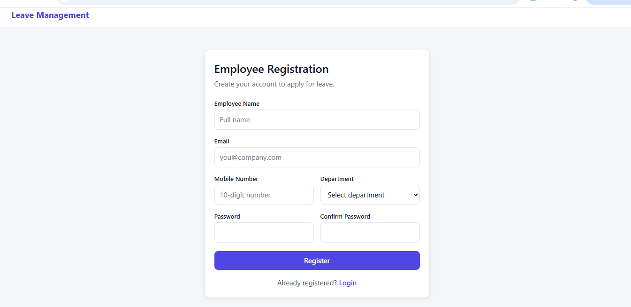
Field | Explanation
Employee Name | The employee's full name
Email | Used as the login ID, so it must be unique
Mobile Number | A 10-digit mobile number
Department | Chosen from a dropdown, for example IT
Password / Confirm Password | The two values must match
When the employee clicks Register, the account is saved with the role Employee and the status Active. The Login link goes back to the Login page.
How to use this screen
- Open the app and click Register here on the Login page.
- Enter your full name, email and 10-digit mobile number.
- Select your department from the dropdown.
- Enter a password, then type the same password in Confirm Password.
- Click Register. Your account is created, and you can now log in with this email and password.
Purpose: Only registered employees can apply for leave. Registration also stores the department and contact details that the admin sees in the Employees tab.

Step 2 – Login
Employees and the admin both use this same Login page. The app checks the email and password, then sends each user to the right dashboard for their role.
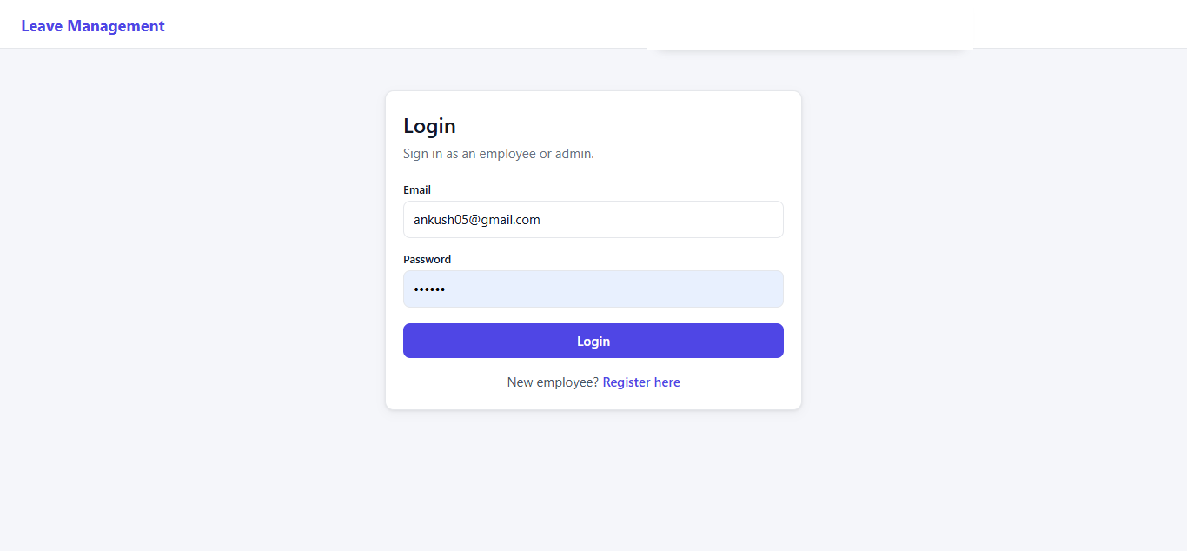
- Email and Password: the credentials entered at registration.
- Login button: on success, an Employee goes to the Employee Dashboard and an Admin goes to the Admin Dashboard.
- Register here: opens the Employee Registration page for new users.
After login, the header shows the user's name, their role (Employee or Admin), and a Logout button.
How to use this screen
- Enter your registered email address.
- Enter your password. It is hidden as dots for security.
- Click Login.
- The app opens the dashboard for your role: Employee Dashboard or Admin Dashboard.
Purpose: Login identifies who the user is. That decides what they can see and do: an employee sees only their own leaves, while the admin sees every employee's pending requests.

Step 3 – Employee Dashboard (My Leaves)
After login, the employee sees a welcome message and a summary of all their leave requests. The top line shows the employee ID and department, for example "Employee ID 3 · IT".
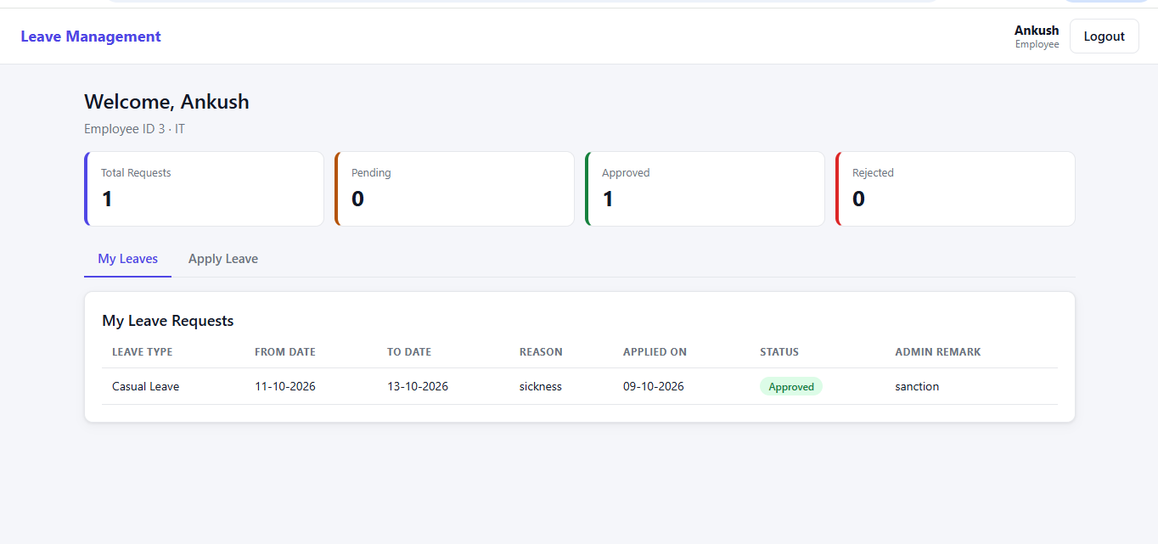
The four summary cards:
Card | What it counts
Total Requests | All leave requests the employee has applied for
Pending | Requests still waiting for the admin's decision
Approved | Requests the admin approved
Rejected | Requests the admin rejected
The page has two tabs: My Leaves and Apply Leave. The My Leaves tab lists every request with Leave Type, From Date, To Date, Reason, Applied On, Status and Admin Remark.
How to read this screen
- Check the four cards for a quick count of your requests by status.
- Look at the Status column to see where each request stands: Pending (yellow), Approved (green) or Rejected (red).
- Read the Admin Remark column for the admin's comment on your request.
- To request new leave, open the Apply Leave tab.
Purpose: This is the employee's home page. It shows the full history of their leave requests in one place, so they don't need to ask the admin for updates.

Step 4 – Apply Leave
The employee opens the Apply Leave tab and fills in a short form. The note on the form says the request goes to the admin with the status Pending.
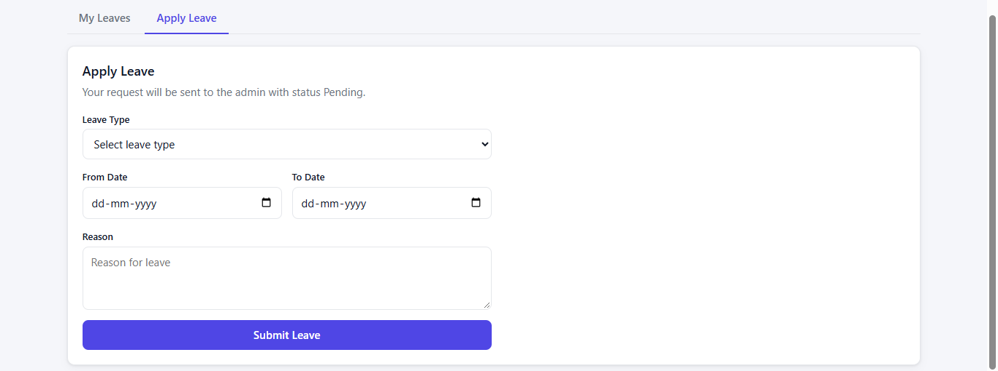
Field | Explanation
Leave Type | Chosen from a dropdown, for example Casual Leave
From Date | The first day of leave (dd-mm-yyyy)
To Date | The last day of leave; it cannot be earlier than From Date
Reason | A short reason, for example sickness
The employee clicks Submit Leave to send the request.
How to use this screen
- Select the Leave Type.
- Pick the From Date and To Date using the date pickers.
- Write a short Reason for the leave.
- Click Submit Leave.
Purpose: This form creates a new leave request. Every new request is saved with the status Pending and sent to the admin for a decision.

Step 5 – Leave Submitted (Status: Pending)
After submitting, the employee sees the green message "Leave request submitted. Status: Pending." The new request appears at the top of My Leave Requests.
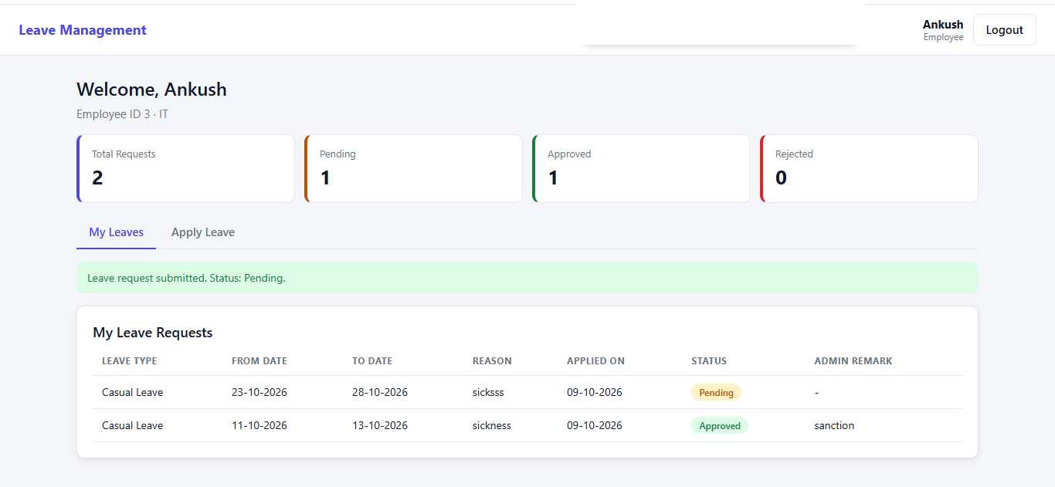
- The new request (23-10-2026 to 28-10-2026) shows a yellow Pending badge, and its Admin Remark is "-" because the admin has not acted yet.
- The cards update: Total Requests goes from 1 to 2, and Pending goes from 0 to 1.
- The older request (11-10-2026 to 13-10-2026) still shows Approved with the remark "sanction".
Purpose: The success message confirms that the request was saved. The Pending status tells the employee that the request is now waiting for the admin, and that they should check back later for the decision.

Step 6 – Admin Dashboard: Review the Request
The admin (rohit) logs in and lands on the Admin Dashboard. Ankush's new request is waiting under Pending Leave Requests.
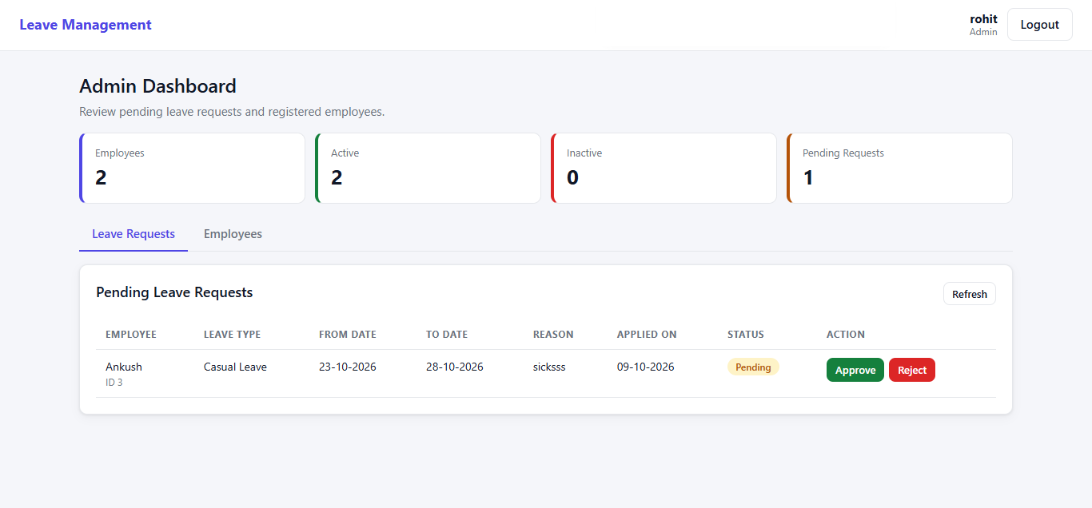
The four summary cards:
Card | What it shows
Employees | Total registered employees (2)
Active | Employees whose accounts are active (2)
Inactive | Employees whose accounts are inactive (0)
Pending Requests | Leave requests waiting for a decision (1)
The page has two tabs: Leave Requests and Employees, which lists the registered employees. Each pending row shows the employee's name and ID, Leave Type, From Date, To Date, Reason, Applied On and Status.
In the Action column the admin chooses:
- Approve: the request becomes Approved.
- Reject: the request becomes Rejected.
The admin can add a remark (for example "sanction"), which the employee later sees in the Admin Remark column. Refresh reloads the list.
How to use this screen
- Log in as the admin.
- Check the Pending Requests card to see how many requests need a decision.
- In the Leave Requests tab, read each request's dates and reason.
- Click Approve to accept the leave or Reject to decline it.
- Click Refresh to load any requests submitted since the page opened.
- Open the Employees tab to view all registered employees.
Purpose: This is the admin's control panel. It puts every pending request in one list, so the admin can decide on each one quickly and keep track of employee accounts.

Step 7 – After the Admin's Decision
Once the admin approves or rejects a request, it leaves the admin's pending list, and the employee sees the result on their dashboard.
Admin view: Pending Requests drops to 0, and the list shows "No pending leave requests."
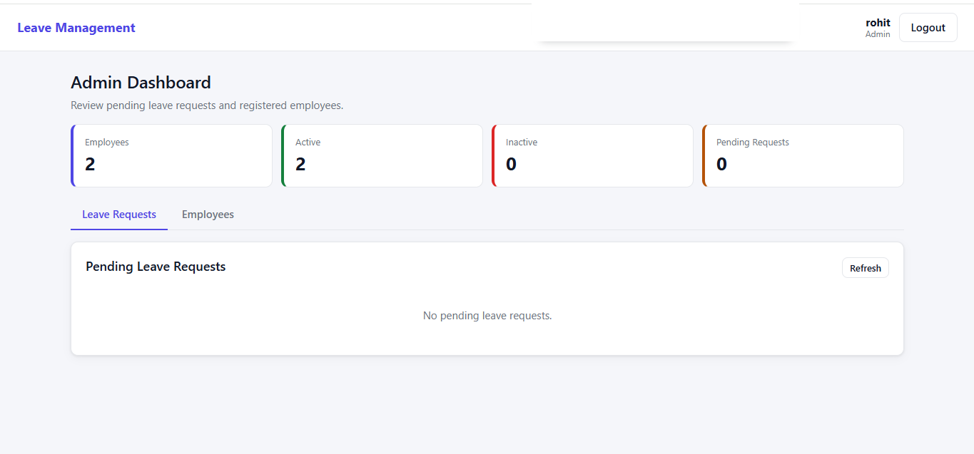
Employee view: the request shows a green Approved badge (or a red Rejected badge) along with the admin's remark. The cards update to match: here Pending is 0 and Approved is 1.
Purpose: This step closes the loop. The admin's pending list is cleared, and the employee gets the decision and remark directly on their dashboard, with no email or phone call needed.

Leave Status Lifecycle and Screen Summary
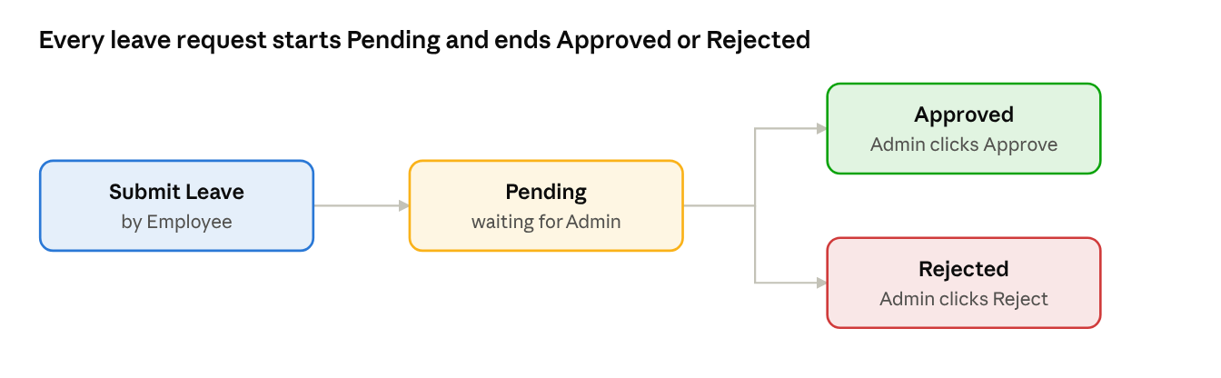
leave status lifecycle · 3 statuses
Only the admin can move a request out of Pending. Approved and Rejected are final statuses.
Step | Screen | User | Main action
1 | Employee Registration | Employee | Create an account
2 | Login | Employee / Admin | Sign in and go to the dashboard for the role
3 | Employee Dashboard – My Leaves | Employee | View requests and their status
4 | Apply Leave | Employee | Submit a new leave request
5 | My Leaves after submit | Employee | See the new request as Pending
6 | Admin Dashboard – Leave Requests | Admin | Approve or reject a pending request
7 | Both dashboards after the decision | Admin, Employee | See the final status and remark

